Pokhara University

Level: Bachelor | Semester – Fall | Year : 2009
Programme: BE |  | Full Marks : 100
Course: Power System analysis |  | Time : 3hrs.

Candidates are required to give their answers in their own words as far as practicable.
The figures in the margin indicate full marks.

Attempt all the questions.

1. | Derive the expression for calculating the internal and external flux linkages of conductor carrying current. Use these expressions to derive the equation for the inductance of a single phase line. | 15
2. | - What is nominal -circuit? Derive for a medium length line the sending end voltage and current relations in terms of receiving end voltage and current considering nominal -configuration.  - A 10 km long 3-phase line has a resistance of 5.54 ohms per phase and inductive reactance of 5.31 ohms per phase. The sending end voltage is 11 kV. The receiving end load is 1.5 MW at a power factor of 0.8 lagging. Find the receiving end voltage and line current. | 7  8
3. | - Derive expressions for “static load flow equations” considering n-bus system.  - Determine Y_{bus} for the 4-bus system shown in Fig. 1. The line series impedances are given in Table 1. Each line has a total shunt admittance of j0.08 pu. Draw also the network diagram. | 7  8
 | Table - 1
Bus to bus | 1-2 | 2-3 | 2-4 | 3-4 | 1-3
Line Impedance (pu) | 0.2+j0.8 | 0.3+j0.9 | 0.25+j1.0 | 0.2+j0.8 | 0.1+j0.4
 | 2  1  3  4  Fig. 1  OR  Starting from the N-R Load flow equation [Jacobian] [Correction] = [Mis-match] for a typical 4-bus network, derive the Fast Decoupled Flow equations :  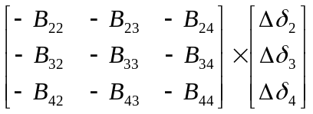=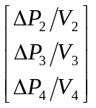  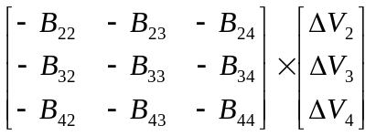=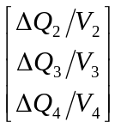 | 15
4. | - Explain the concept of equal area criterion. How it can be used to study the stability of a single machine swinging with respect to an infinite bus.  - A two-pole 50 Hz, 60 MVA turbo-generator has a moment of inertia of 9x10³ kg-m². Calculate  - kinetic energy in MJ at rated speed.  - the inertia constant (H) and the angular momentum (M)  - the inertia constant on 50 MVA base. | 8  7
5. | - Show that when ‘n’ generators in the same plant (or close enough electrically so that line losses may be neglected) are operating in parallel and supplying power into a transmission network, the most economical scheduling of loads is obtained when their incremental cost of production are equal.  - Determine the incremental cost of received power and the penalty factor of the plant shown in Fig. 2 if the incremental cost of production is 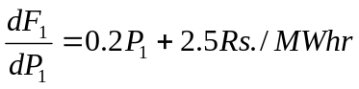.  P_{D}=9 MW  P₁=10 MW  Load  Fig. 2  P_{L}=1 MW | 8  7
6. | - Describe the different possible method of frequency regulation of two machines running in parallel as shown in Fig. 3.  Tie-line  Load 1  Load 2  G₁  G₂  Fig. 3  - Two generators rated at 200 MW and 100 MW are operating in parallel. The governor settings on the machines are such that they have 2% and 3% droops. Determine the load taken by each machine for a total load of 200 MW. | 8  7
7. | Write short notes on (Any Two)  - Efficiency () and regulation of Transmission Line  - Surge Impedance Loading (SIL)  - Speed Regulation (or Droop) | 5×2

